Money Matters
The 3rd Generation
富不过三代? Chinese proverb,
"You can only keep wealth in the family for three generations."
Judges 2: 1 ‘I brought you up out of Egypt … “I will never break my covenant with you, 7 The people served the Lord throughout the lifetime of Joshua … 10 After that whole generation had been gathered to their ancestors, another generation grew up who knew neither the Lord nor what he had done for Israel. 12 They forsook the Lord, the God of their ancestors, who had brought them out of Egypt. They followed and worshipped various gods of the peoples around them. They aroused the Lord’s anger. 17 They quickly turned from the ways of their ancestors, who had been obedient to the Lord’s commands.19 following other gods and serving and worshipping them. They refused to give up their evil practices and stubborn ways.
Moses - Joshua - Lost
Let’s get Credit
According to one of the most recent reports the average Australian household holds 12 Visas, MasterCards and various store cards. Credit card companies send out more than 10 million new credit card offers every year.
Back in 1972, A man took a challenge to see who could accumulate the most credit cards. Eight years later he won the bet - and broke the world record – by applying for and getting 1,003 credit cards, weighing 16kl and entitling him to $1.75 million in credit.

Biblical issues with Money
The issue of money has been a prominent one from the inception of the church. Jesus spoke a great deal about it himself. Consider this:
a) The gospels contain more warnings against money and its misuse than any other subject.
b) One in every four verses in Matthew, and Luke deal with money.
c) One in every six verses in the New Testament as a whole deals with or makes references to money in some way.
d) Almost half of the parables of Jesus have reference to money in one way or another, particularly warnings against covetousness.
e) The first apostle to fall was Judas. It was probably because of love of money: He sold Christ for money that He never lived to spend! John 12:4-8; Acts 1:25; Matthew 26 14-16; 27:3-10
f) The first sin in the early church concerned the giving of money to the Lord. Note how Satan entered the early church through money, when the spirit of giving was on the people. Acts 5:1-10
g) The sin of “Simon” concerns money and seeking to buy the gifts of God with it. Acts 8:14-24
Why all this talk about money and possessions? Because Jesus understood so well the tremendous influence of this issue in our lives.
o 50% of Christians consider money to the primary indicator of success.
o 19% of Christians believe you can tell how successful a person is by examining what they own.
Three Tithes:
1. The Levitical, or sacred tithe 10% per year (Num. 18: 21, 24).
2. The tithe of the feasts 10% per year (Deut. 14:22-27).
3. The tithe for the poor 10% every third year (Deut. 14:28, 29).
The first tithe: Gen. 14:18-20 & Numbers 18:21-26 & Deuteronomy 12:17 is the sacred tithe, given to the Levites and priests for their service to the temple. This is the tithe we continue to give under the priesthood of Melchizedek in the New Testament. It is the tithe consecrated to God and the furtherance of the gospel and has, therefore, validity for all believers in Christ.
The second tithe: Deuteronomy 14:22-27 The Levitical law required that a Jew had to go up to Jerusalem on certain occasions to celebrate Holy Days (we call the holiday’s periods of vacation for the family). And how should the head of the household provide for the family? By setting aside a second tithe (10%), as in Deuteronomy 14:22-27, for a family experience with a Christian purpose, such as going to a conference, a missions trip, a camp, Christian school fees meetings or just to refresh the family so to review the greatness of God.
The third tithe: Deuteronomy 14:28-29, this was given only every third year to the sojourner, the fatherless, and the widow. This tithe, therefore, was the welfare of the community. In our day this could mean child sponsorship, services groups, food support program, Missions support, Missions trip etc.
Money Theology
The problems with a prosperity theology:
1. Prosperity is a sign of God’s approval.
2. It produces guilt.
3. It creates wrong motives.
Four problems with poverty theology
1. There is a presumption that anyone doing well financially must be doing something dishonest.
2. “God loves me because I’ve given up so much.”
3. They are extremely naive. - These people are dependent upon financial support for everything and they are extremely naive when they tell you — you see if everybody gave it up — where do they get their resources.
4. It can become a manipulative lifestyle.

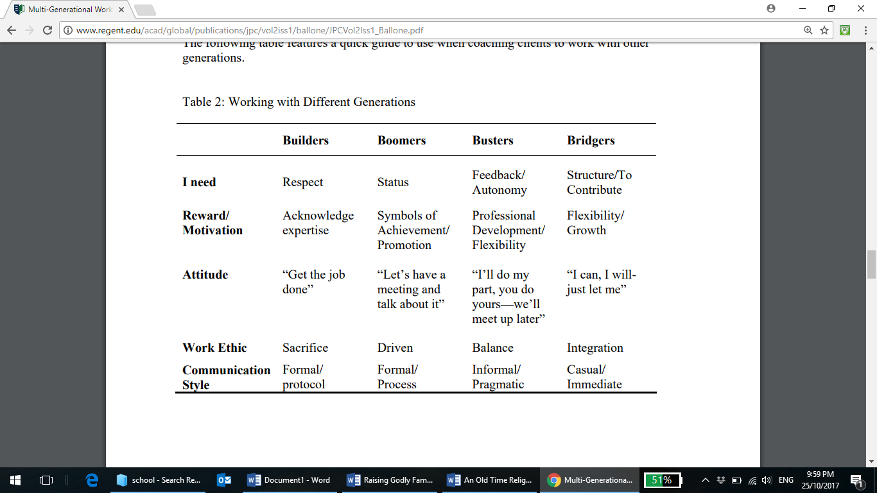
4 generations, with 4 radically different worldviews/needs.
Wealth or Mammon
Matt 6:24 States: no man can serve two masters: for either he will hate one, and love the other; or else he will hold to the one, and despise the other. Ye cannot serve God and mammon. The first time the Bible mentions someone with great wealth, it speaks of a righteous man, Abraham, who "was very rich in livestock, in silver, and in gold" (Genesis 13:2). Later we find God promising that through this man's descendants all nations of the earth would be blessed (Genesis 18:18; 22:18; 26:4). Abraham was wealthy, but he was also "the father of all those who believe" (Romans 4:11).
God is not opposed to his Wealth. In fact, He is the originator of financial blessings (1 Samuel 2:7; Proverbs 10:22) and reminds us that personal diligence can also lead to wealth (Proverbs 10:4).
When we have more money than we need for normal expenses, we are wise to save some for later use. The Bible speaks well of the saver, noting that the ant wisely stores up food for the winter (Proverbs 6:6-11). It speaks favourably of someone who would provide for his children and grandchildren: "A good man leaves an inheritance to his children's children, but the wealth of the sinner is stored up for the righteous" (Proverbs 13:22).

Principals of Wealth
In Deuteronomy 8:18, God says He will give us the power to make wealth. God would never enable us nor give us the power to do the opposite of His will. If He desires to empower us to make wealth, then wealth cannot be mammon. Mammon separates us from God and causes us to be double minded. If wealth is not mammon, then it is important for us to find distinguishing characteristics that separate them. If we can separate wealth from mammon, then we can find the freedom to be empowered to receive wealth.
Look at the story about Jacob and his father in law Laban. Ten times Laban changed Jacob’s wages in 20 years, but God gave Jacob a dream about the spotted sheep and cattle. Jacob knew how to take advantage of an opportunity from the Lord. He made a deal with Laban that included the spotted livestock as part of his wages. Before long Jacob owned more stock in the company than Laban. Sheep and cattle are wealth. God gave the wealth of Laban to Jacob through the transfer of cattle and sheep. Laban and his sons were angry with Jacob, but God commanded Laban saying, “Don’t you dare harm him!” God can protect your health and your wealth.

The Prodigal and Mammon
We have heard a lot about the prodigal son from the view-point of redemption, but let’s look at him in reference to the spirit of mammon (Luke 15:11-32). The prodigal son is one of the best biblical examples concerning the transfer of wealth into the world’s system and the attack that can come.
In the world system of Money, there can be a downward spiral. We sell true wealth (land, houses, cattle, flocks, silver and gold bullion) to attain money. Money is what make the world go round according to the world system. In other words, money is needed to buy and sell. When we sell wealth and replace it with money, we have the tendency to buy treasures and riches rather than invest in wealth. (Treasures are the things we fill our homes with that give us enjoyment or fulfil a certain purpose for our daily life style). When we buy treasures alone, our money loses value, because treasures wear out and depreciate in worth. Most of the world spends money for daily existence and for the treasures the world offers. Very few spend to attain riches and more importantly the wealth that God empowers us to receive.
The Lord teaches us that we should not despise mammon but understand the principals governing it and then walk wisely concerning its use. We must remember that mammon is God’s wealth personified by men. The following scripture will enlighten us to a balanced approach to mammon.
Luke 16:9 And I say unto you, Make to yourselves friends of the mammon of unrighteousness; that, when ye fail, they may receive you into everlasting habitations. The spirit of the mammon is much stronger than the money it controls. Many of us have fallen into the same trap and need freedom. We need to come to our senses as the prodigal did and run to our heavenly father for the wisdom to use properly what He has placed within our hands.
My future
HOW LONG WILL $250,000 LAST?
Year | Start of Yr. | Income | Expenses | End of Yr.
1 | $250,000 | $17,237 | $50,000 | $217,237
2 | $217,237 | $14,979 | $51,000 | $181,216
3 | $181,216 | $12,495 | $52,020 | $141,691
4 | $141,691 | $9,770 | $53,060 | $98,401
5 | $98,401 | $6,785 | $54,122 | $51,064
6 | $51,064 | $3,521 | $55,204 | -$619
Assumptions: 7% gross return, 2% inflation, 0% tax, 1.5% management fees.

The ABC of DIY Wealth Building
In a recent survey Thomas J. Stanley, author of the best seller Thee Millionaire Next Door, found that poor people played the lottery almost three times more often than wealthy people. He noted that wealthy people held the common belief ‘that it was better to burn a few dollars with a match each week than to lay money for the lotto!’
Wealthy people are not gamblers, but simply ordinary people who understand the wealth building principals necessary to succeed. Once you know these principals, you too will be able to make confident investment decisions for yourself, without having to pay other people to do it for you.
Let’s look at the facts and philosophies underlying these principals. I call them the ABC of DIY wealth building. We begin by discussing why having the right ‘Attitude’, preparing a Blueprint and staying committed are so important. We analyse two different kinds of ‘Debt’ then compare ‘Education’ with schooling. Finally, we investigate why ‘Fear’ can stifle any well laid wealth building plan.
E = MC2
where E = Economy
M = Money
And C = Confidence

Debt allows Leverage
Many people wrongly believe that good and bad debt are synonymous with small and large debt. For example, they think that it’s ok to borrow $ 16,000 for a new car, but not to borrow $ 160,000 for an investment property. In fact, a small debt for consumable items can destroy wealth. A large debt on appreciating assets can build wealth.
Let’s imagine two people who each can spare $ 2,700 a year. Bill Poor can’t wait to get behind the wheel of a new $ 16,000 car that will cost him $ 2,700 a year over 10 years. Richie Cash decides that with his $ 2,700 a year, he can buy a rental property for $ 160,000. Why should a property worth ten times that of a car cost the same amount each year? Let’s see.
Bill Poor gets a great deal from his local bank and borrows the entire $ 16,000, with a personal loan at 11.5%. In the first year, his repayment of $ 2,700 consists of roughly $ 1,793 in interest and $ 907 towards the principal, but over ten years, he will clear the loan and own the car outright.
Richie Cash borrows $166,000 ($160,000 property price and $ 6,000 purchasing and borrowing costs) at 8.5% on interest only. His interest bill is $ 14,110 a year, but with no principal payments, after 10 years he still owes $ 166,000. However, in the first year, with $ 10,400 in rent and a tax refund of $ 3,626, Richie pays only $ 2,684 of his total expenses of $ 16,710 ($14,110 interest plus $ 2,600 in property expenses). The table below show what happens over ten years
The Way to Wealth – Car or Property?
Car ($) |  |  |  |  |  | Property ($)
Value | Debt | Equity | Yr. |  | Value |  | Debt | Equity
16,000 | 16,000 | 0 | 0 |  | 160,000 |  | 160,000 | -6,000
14,240 | 15,093 | -853 | 1 |  | 167,200 |  | 166,000 | 1,200
12,674 | 15,093 | -1,402 | 2 |  | 174,724 |  | 166,000 | 8,724
11,280 | 12,936 | -1,656 | 3 |  | 182,587 |  | 166,000 | 16,587
10,039 | 11,658 | -1,619 | 4 |  | 190,803 |  | 166,000 | 24,803
8,934 | 10,225 | -1,291 | 5 |  | 199,389 |  | 166,000 | 33,389
7,952 | 8,618 | -666 | 6 |  | 208,362 |  | 166,000 | 42,362
7,077 | 6,817 | 260 | 7 |  | 217,738 |  | 166,000 | 51,738
6,299 | 4,797 | 1,502 | 8 |  | 227,536 |  | 166,000 | 61,536
5,606 | 2,532 | 3,074 | 9 |  | 237,775 |  | 166,000 | 71,775
4,989 | 0 | $ 4,989 | 10 |  | 248,475 |  | 166,000 | $ 82,475
Assumptions: Car depreciates at 11%; property value increases at 4.5%

Which Path Would YOU Choose?

$ 2,700/yr
Loan Payment

$ 16,000 $160,000
Car Now Property

$ 4,989 $ 82,475
Equity in Car After 10 Years Equity in Property

When you next think that a big debt is a bad debt, think of the following conversation between two young boys.
1st boy: We are so poor that my Dad owes the bank $2,000.
2nd boy: We are so rich that my Dad owes the bank $2,000,000

AFFORDABILITY
It is thought that shares are much more affordable investment because they can be bought in small lots compared to the cost of a rental property. While there is no question that investment in shares is within the reach of most people, I want to show you why investment in residential property can be easily affordable.
Comparison of Returns from Property and Land
 | Property | Vacant land | Vacant land
 | (house & land) | (no building) | (no building)
Value | $160,000 | $65,000 | $65,000
Loan | $166,000 | $67,000 | $67,000
Capital growth | 4.5% | 4.5% | 20%
Inflation | 2.0% | 2.0% | 2.0%
Growth above inflation | 2.5% | 2.5% | 18.0%
Interest payments | $14,110 | $5,695 | $5,695
Rent | $10,400 | 0 | 0
Tax credits | $3,626 | 0 | 0
Expenses | $2,600 | $1,300 | $1,300
Bill & Mary’s cost | $2,684 | $6,995 | $6,995
Value after 5 years | $199,398 | $81,002 | $161,741
Equity after 5 years | $33,398 | $14,002 | $94,741
Rate of return (IRR) | 41% | -29% | 41%

Gross Returns from the Capital Cities
 | Syd. | Mel. | Bris. | Adel. | Perth. | Canb. | 6-City | Hobt.
Cap growth | 7.8 | 9.2 | 8.3 | 6.7 | 7.0 | 7.5 | 7.8% | 5.8
Gross yield | 7.6 | 7.9 | 7.4 | 8.5 | 8.0 | 7.7 | 7.8% | 10.0
Gross return | 15.4 | 17.1 | 15.7 | 15.2 | 15.0 | 15.2 | 15.6% | 15.8

Renting versus buying
While most financial advisors agree that owing your own home should be a top priority, there is a controversial school of thought that renting is better than buying. According to a report by the Australian Institute of Family Studies, ‘many people would be better off investing their equity and renting’. While I agree that this is possible, particularly if you rent while buying an investment property, this kind of thinking fails on two points. First, it fails to acknowledge that home ownership benefit are not that the tenant-come-investor will be mentally disciplined enough to divert all loose change into their investments.

Typical Tax Deductions
 | Deductions | Cash | Non – Cash
Accounting fees | 20 | 20 | 0
Advertising | 10 | 10 | 0
Bank charges | 0 | 0 | 0
Body corporate fee | 0 | 0 | 0
Borrowing costs | 500 | 0 | 500
Cleaning | 20 | 20 | 0
Council rates | 900 | 900 | 0
Depreciation - building | 2,000 | 0 | 2,000
Depreciation –furniture | 2,700 | 0 | 2,700
Electricity / Gas | 0 | 0 | 0
Fire Levy | 72 | 72 | 0
Gardening & mowing | 20 | 20 | 0
Insurance | 130 | 130 | 0
Interest on borrowing | 14,110 | 14,110 | 0
In-house video/PABX | 0 | 0 | 0
Land tax | 0 | 0 | 0
Letting fee | 200 | 200 | 0
Legal expenses | 0 | 0 | 0
Lease costs | 0 | 0 | 0
Pest control | 0 | 0 | 0
Property agent’s fees | 858 | 858 | 0
Quantity surveyor’s fee | 200 | 200 | 0
Repairs & maintenance | 100 | 100 | 0
Replacement (linen, etc) | 0 | 0 | 0
Secretarial fees | 20 | 20 | 0
Security patrol fees | 0 | 0 | 0
Stationary/postage | 20 | 20 | 0
Telephone | 10 | 10 | 0
Travelling allowance | 20 | 20 | 0
Worker’s compensation | 0 | 0 | 0
Your business deductions | 0 | 0 | 0
Total deductions | $21,910 | $16,710 | $5,200

What if the inflation rate changes? - The fuzzy logic of how inflation affects capital growth
High inflation = High capital growth = Good for property
Low inflation = Low capital growth = Bad for property
The fuzzy logic of how inflation affects negative gearing
High inflation = High interest = High tax refund = -ve gearing is great
Low inflation = Low interest = Low tax refund = -ve gearing is dead

Comparing the Past Five Decades
 | 1960’s | 1970’s | 1980’s | 1990’s | 2000’s
Inflation | 3.0% | 11.05 | 8.0% | 2.1% | 3.1%
Capital growth | 6.5% | 14.5% | 11.5% | 4.7% | 5.1%
Interest rate | 4.5% | 7.5% | 13.5% | 8.5% | 8.2%

INVESTING INTO THE KINGDOM
Just like personal wealth development we can develop wealth into the Kingdom of God. Wealth in all case is the way that we manage and implement and plan ahead the wellbeing of either our self or the Kingdom of God. As you see in Eph 2:18-19 the greatest wealth is becoming a part of the household of the kingdom of God. And as such as we grow in our own personal live then the Kingdom of God can grow.

How can we invest into the kingdom of God?
Mal 3:10 tells us to bring the entire tithe an all the offering into the store house so that there might be meat or food in the house of God. It is very clear that we are to bring our tithe and make a deposit into the household, and that especially towards the ministry, yet as we see throughout the scripture the ministry did much more than tithe it received offerings that helped to build the temples, the poor, missionary outreaching, the economy and the wellbeing of the needy.
What about if we consider our own giving, as that which is like in Matt 25 where are given talents and are told to go and invest them so that when the master returns our talents are that which have been invested into the kingdom.

Negative Gearing on Giving.
If we choose to invest into the kingdom of God we can do so in the same way we do in our own personal development e.g. with property, shares or some other equity if we choose do this it can be very simply drawn out in following graph e.g.
Say we choose to give $30.00 a week to the building fund which would add to $1,560 a year this would be a great gift , but could it be multiplied and be an advantage to create $100,000.00 to the church immediately and cost exactly zero in the long term. Follow through he graph and find out how this works.
After seeing the above we see that there are many opportunities that every Christian are given that they can use what talents they have, what wisdom, and what ability they have to enlarge the kingdom of God in this place.

FINANCIAL FREEDOM
Is all about investing – But what into??
- The Kingdom
- The Church
- Your Spirit
- Your Family
- Your Health
- Your Future
- Your Assets

Let’s see that we give ourselves to God so he may use all that we are.

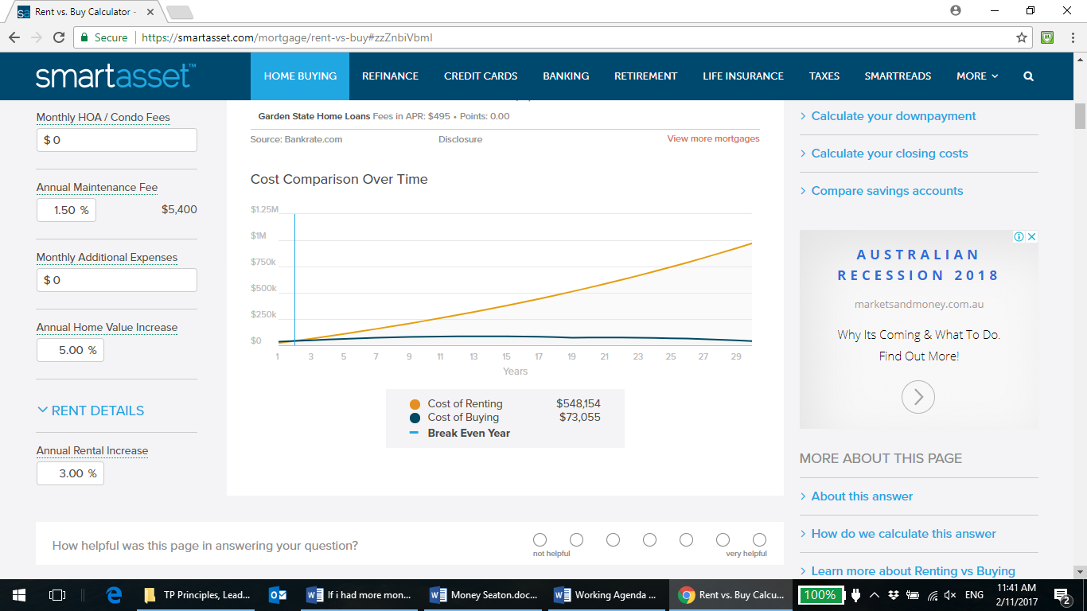
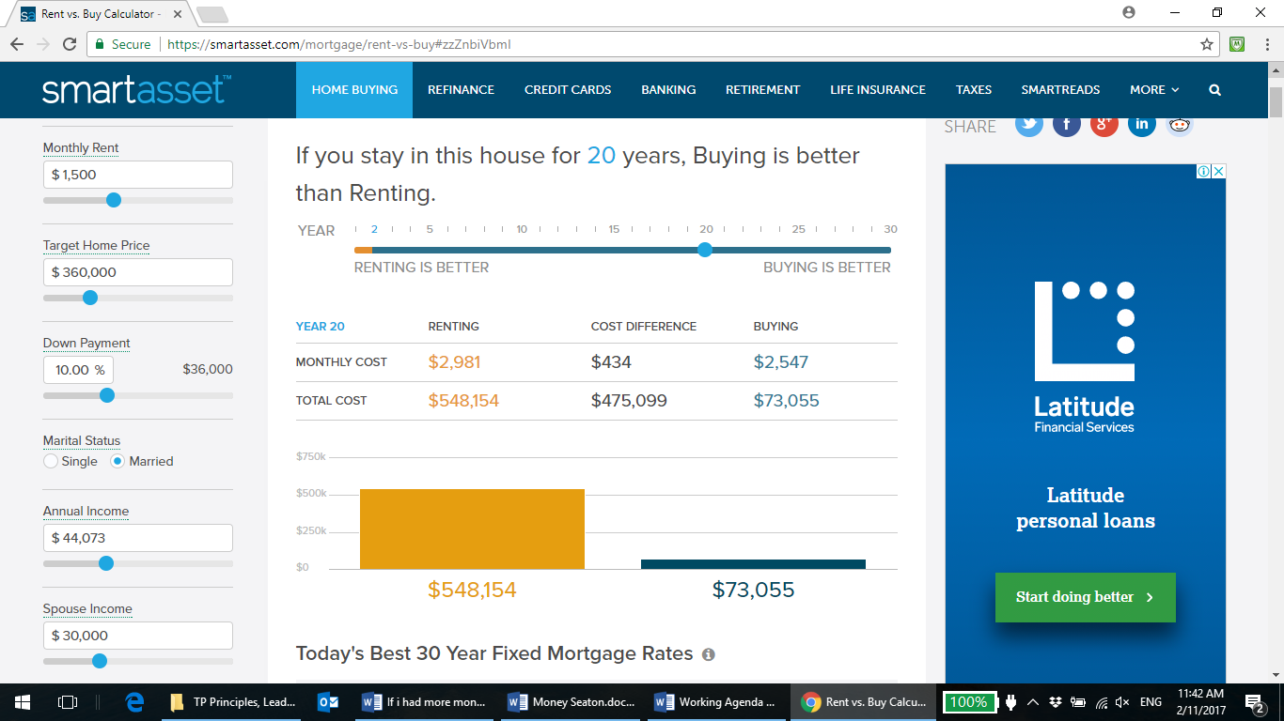

Church property ownership
We often began in a lounge room. But very quickly with growth we move into a room in a local school, then the basketball court. Now the church is spending money on property and with set up and pack down. In the end, it became very clear that spending our property dollars on renting facilities will hindering our ability to.
Six reasons why

1. Lack of control
We were always vulnerable to our landlords.
We need to always considered the minimum goal to think out into three generations – my children’s children. That means thinking about the work over the next 70yrs. Will renting provide the appropriate and most helpful platform for a growing work over that length of time?

2. Growth
All of our ministries have been restricted by renting facilities. Youth work and women’s ministry have been hardest hit.

3. Storage, setup, pack down
This was always a headache, but in the last few years we resorted to buying a large truck which stored every stick of equipment required to run our church meetings.

4. Complexity
A great deal of time and energy (and heart ache) is spent on coordinating, communicating and managing. Where a funeral, a wedding, an AGM going to be held? In the end we simply ran out of halls.

5. Lack of place and community identity
A group that has no permanent physical home in an area feels to many like a fly-by-night cult. No doubt the early church overcame these to grow and we certainly saw God bless despite all this.

6. But then the last one – Cost
We pay hall rentals, and property management. This is without factoring in wear and tear. Without owning property we were still spending a lot of money on property! The credo – 'money on people not property' OR 'invest in ministry not buildings' - facilities should trigger growth.
Should church plants buy their own facilities?
Certainly not always; There will no doubt be some contexts and situations where this will be either impossible. But in the vast majority of plants, there will come a time when moving from renting to ownership will serve the cause of the gospel.

The CHURCH BUILDING rent vs buy question
Just like our own family situation! Put it to people to consider tithing their home mortgage for the purpose of establishing a church home. If everyone did this we could buy a church facility many times over. People are far more ready to give to property, properly conceived and clearly serving an appropriate vision. The money is there!
It is certainly all about Christ. But there is much that builds a platform to preach him and minister to people. Building is one such thing.

Purchase a Church Building Calculations
Church Building income $4,500  Rent $2,000  Purchase $1,000,000  Maintenance $2,000 | Interest 5%  Inflation 3%  Property Growth 8%
Over 50 Years
